Installing Microsoft Visual Studio 2019

During this course we will be using an industry standard Development Environment to write, debug and run our code.

Microsoft Visual Studio is the IDE of choice for C# developers and can be downloaded for free on the Microsoft Developer site.

Note: You will need Windows 10 on your PC / Laptop and it is advisable to update it to the latest available version.

Downloading Microsoft Visual Studio 2019 Community

The Microsoft Development Environment, libraries and tools are available as a massive free download from the Microsoft Dev Centre [http://developer.microsoft.com/en-us/windows/downloads] downloads page.

Enter the link [http://developer.microsoft.com/en-us/windows/downloads] into Internet Explorer (or a web browser of your choice) and it will steer you to the **Downloads and tools for Windows 10** page.

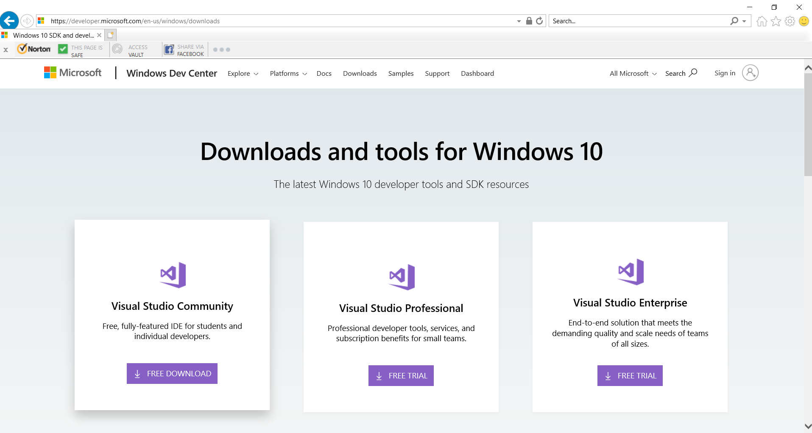

When the page loads, click on the **Visual Studio Community Free Download** button.

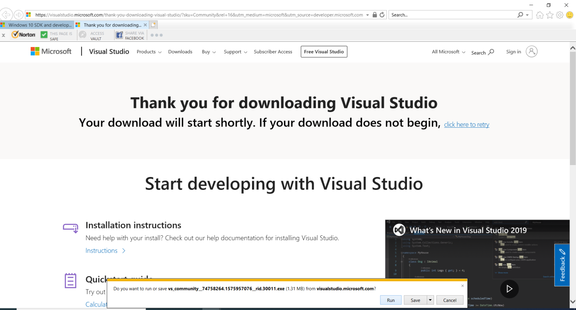This will navigate you to the **Thank you for downloading Visual Studio** page.

When the **Do you want to run or save VS_ccommunity.exe (1.31KB) from visualstudio.microsoft.com?** prompt appears, at the bottom of the page…….Click the **Run** button option.

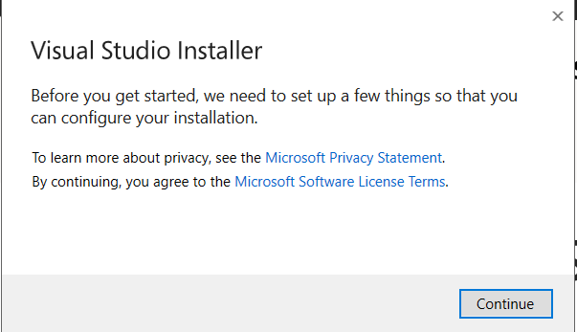

The installer will prompt you to set up some configuration options,

Click the **Continue** button.

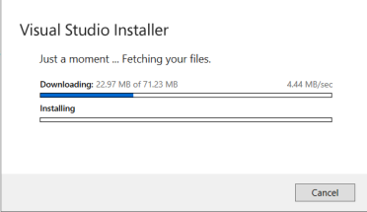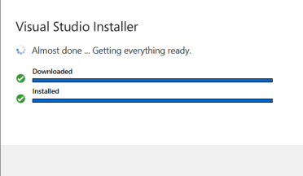The installer will retrieve the install files….

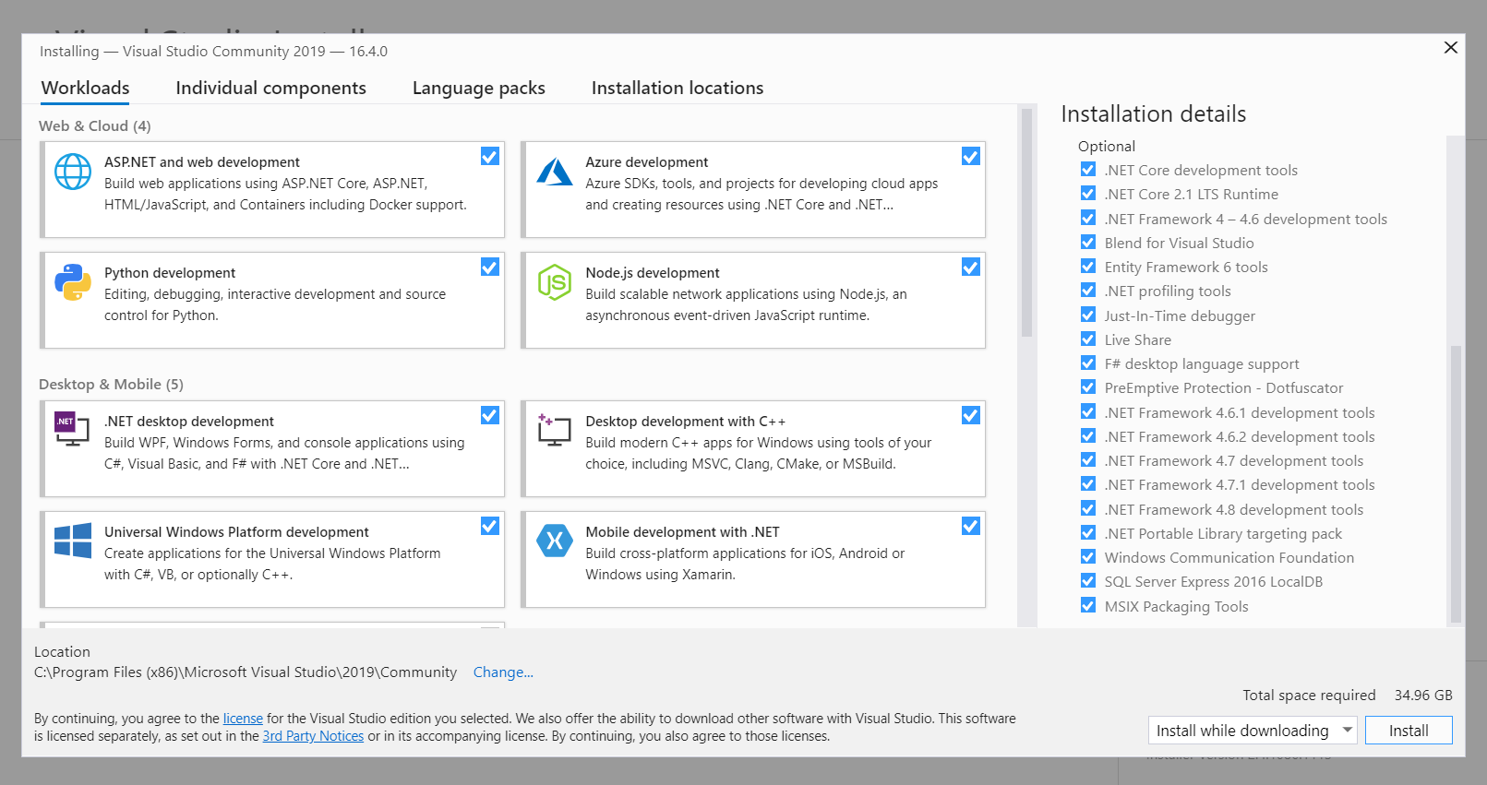

When the installation window appears you can set the download options you want, I clicked them all for the first install. You can also add language packages under the ‘Language packs tab’ and specialised packs under the ‘Individual components’ tab.

When you have selected your configuration click the **Install** button.

Note: After installation you can install any workloads or components you did not install initially by in Visual Studio going to **Tools** > **Get Tools and Features...**, this will open the Visual Studio Installer.

The installer will eventually appear, this may take some time depending on your computers specification…….

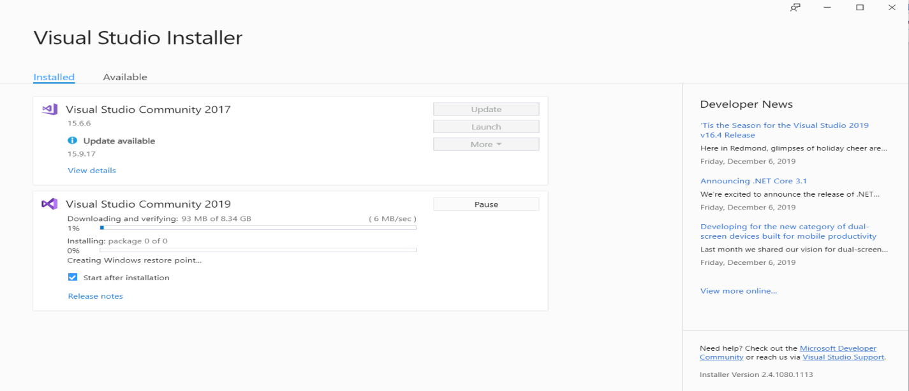Be patient, it will eventually appear…………………..

The installation process will then begin (on my system 2017 is also installed so an update is flagged)….

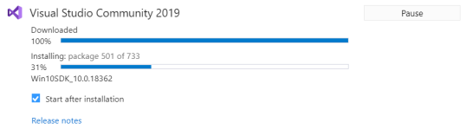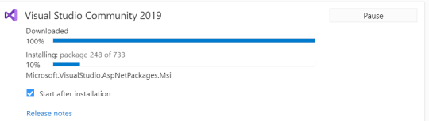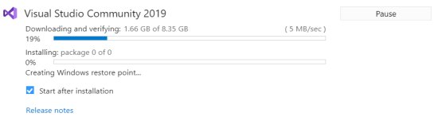The installation may take a long time. Be patient, it will eventually install…………………..

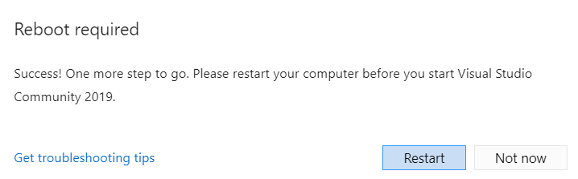

When installed successfully you will be promoted for a reboot… click the **Restart** button.

**Opening** **the Development Environment**

To open the Microsoft Development environment select the following.

Click the on the **Windows**  button in the lower left corner of your screen or press the  **Windows Key** on your keyboard.

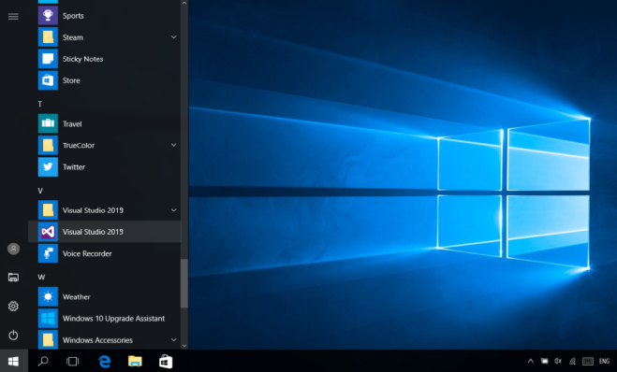

When the programs list appears.

Scroll down the programs list until you reach the **V** section and then select (by clicking on it) the **Visual Studio 2019** application.



Note: You can also search for Visual Studio 2019 in your search window or click on the shortcut if you have one on your desktop.

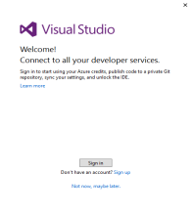

When the insulation is complete you may be asked to connect up all your developer services, for now just select the **Not now, maybe later** option by clicking on it.

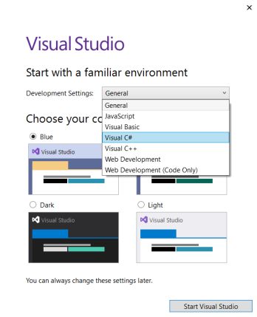**Opening** **the Development Environment for the First Time**

If this is the first time that you have used the Development Environment then the **Start with a familiar environment** window may appear.

This will give you some options to configure the environment to a specific language, setup and feel.

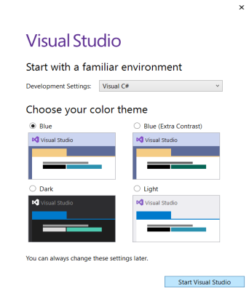

Select **Visual C#** from the **Development settings:** list.

Select the **Blue** option from the **Choose your color theme** options.

Click the Start Visual Studio button to open the development Environment.

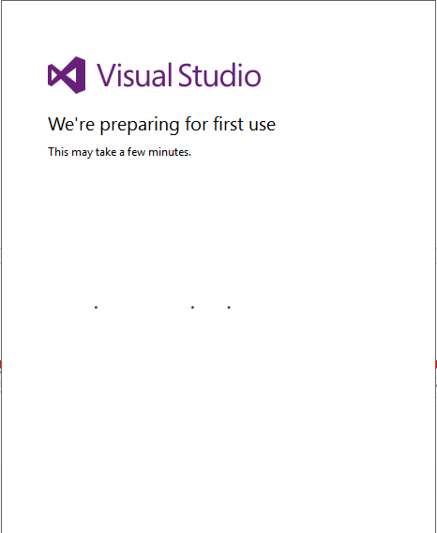

It will take a while to configure the environment.

As the prompt will tell you.

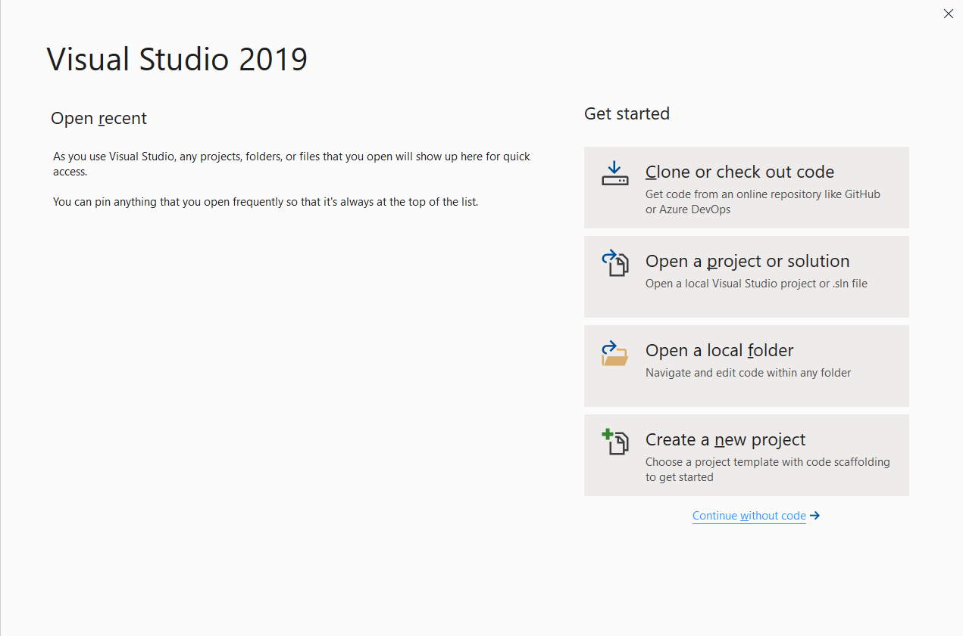When the Visual Studio 2019 screen appears click the ‘**Create a new project**’ button.

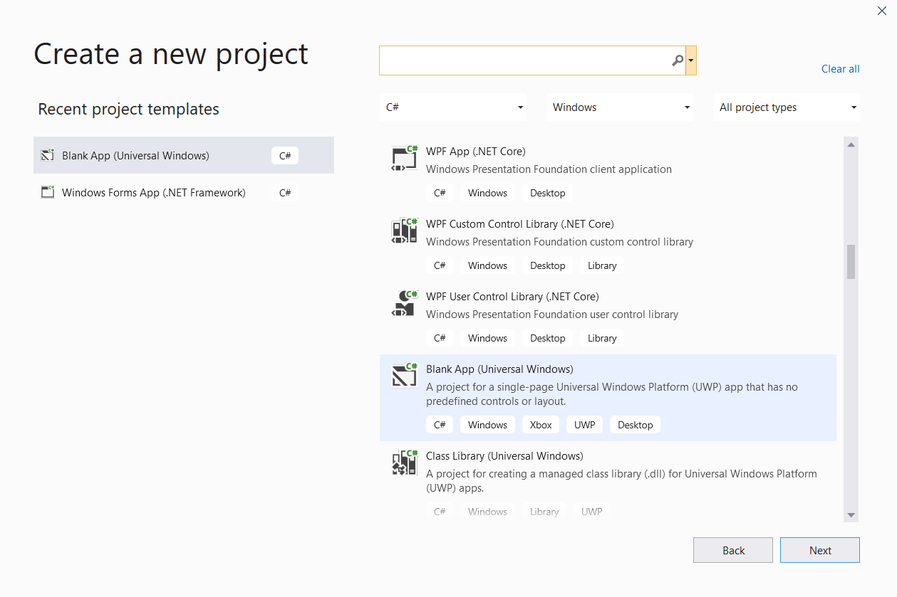At some point the **Create a New Project** screen will load up, allowing you to select a project type to work with.

**CONGRATULATIONS**

You have completed the first step of downloading a commercial ***Integrated Development Environment***……***.*** now we can get on with the course…...

